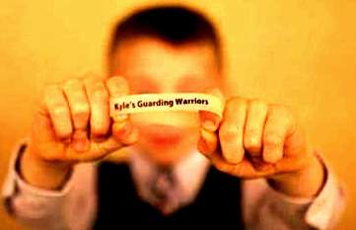



**KYLE’S GUARDING WARRIORS**

**Help support Kyle and his Guarding Warriors 7th annual fundraiser**

**Benefiting Mercy Flight**

**SOUPFEST AND BASKET RAFFLE**

**Event date : February 16, 2019**

**Time – 6p-9p**

**Wheatfield Community Center**

**2790 Church Road**

**Wheatfield, NY 14120**

**$10 per person for all you can eat soup, dessert and roll with a variety of choices!  
While supplies last**

**Raffle ticket prices**

**1 sheet for $5 and 5 sheets for $8**

**50/50 – 1 for $1**

**10 for $5**

[www.kylesguardingwarriors.com](http://www.kylesguardingwarriors.com)

**COME JOIN US!!!**